|  |  |  |  |
| --- | --- | --- | --- |
| **Cancer Cohort** | **Number of Samples** | **Median Mutations per sample** | **Log of Median Mutations** |
| **SKCM overall** | **465** | **244** | **2.3873898** |
| subset1 | 152 | 249.0 | 2.3961993 |
| subset2 | 130 | 235.5 | 2.3719909 |
| subset3 | 62 | 267.0 | 2.4265113 |
| subset4 | 120 | 240 | 2.3802112 |
| **COAD Overall** | **399** | **89.0** | **1.9493900** |
| subset1 | 235 | 89.0 | 1.9493900 |
| subset2 | 3 | 145.0 | 2.1613680 |
| subset3 | 155 | 86.0 | 1.9344985 |
| subset4 | 5 | 101.0 | 2.0043214 |
| **LUSC Overall** | **490** | **173.0** | **2.2380461** |
| subset1 | 195 | 185.0 | 2.2671717 |
| subset2 | 106 | 164.5 | 2.2161659 |
| subset3 | 31 | 159.0 | 2.2013971 |
| subset4 | 157 | 168.0 | 2.2253093 |
| **LUAD Overall** | **559** | **135.0** | **2.1303338** |
| subset1 | 158 | 160.5 | 2.2054750 |
| subset2 | 163 | 128.0 | 2.1072100 |
| subset3 | 36 | 110.5 | 2.0433623 |
| subset4 | 201 | 122.0 | 2.0863598 |

**Clustered Cohorts Summary Table**

**SKCM**

Subset1

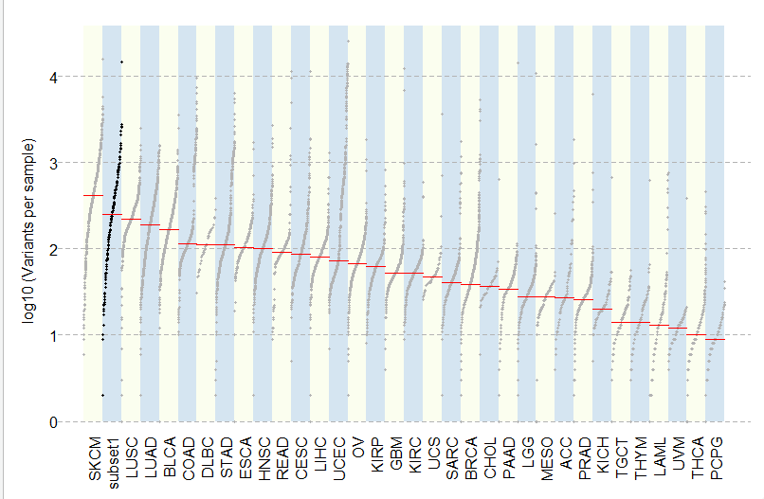

Subset2

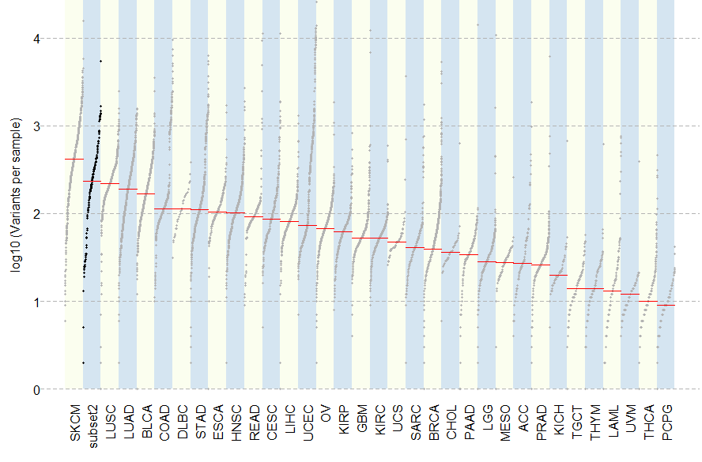

Subset 3

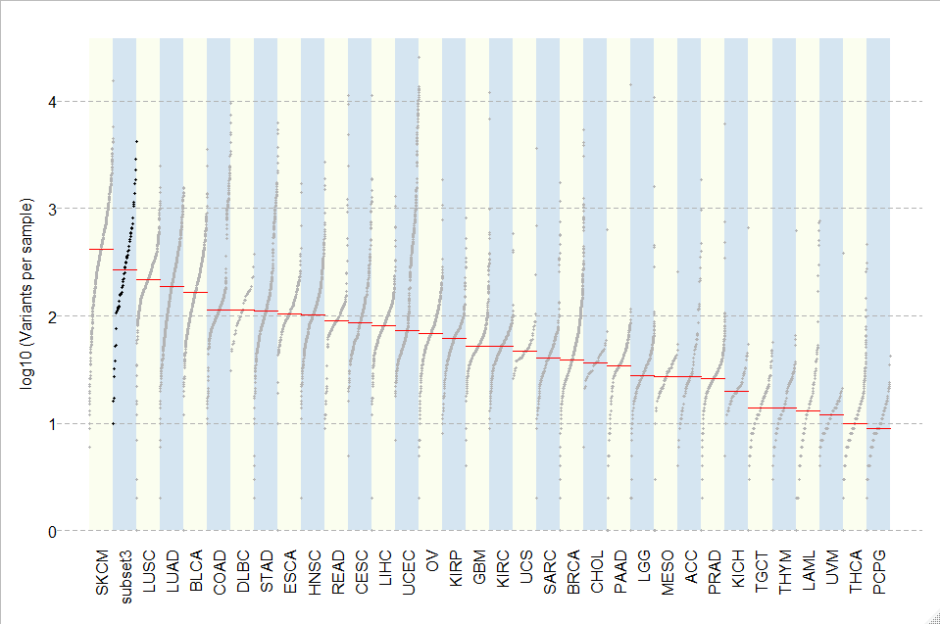

Subset4

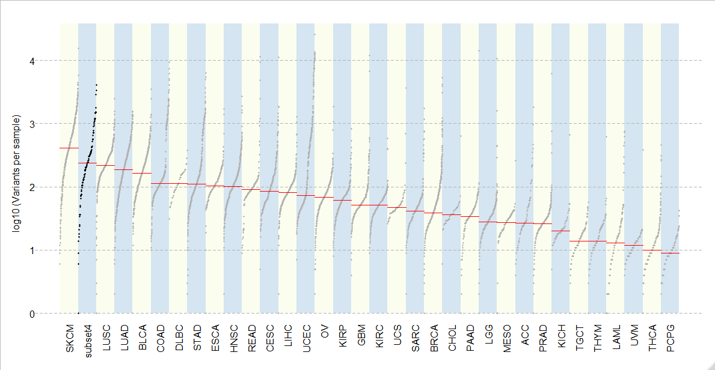

COAD

Subset1

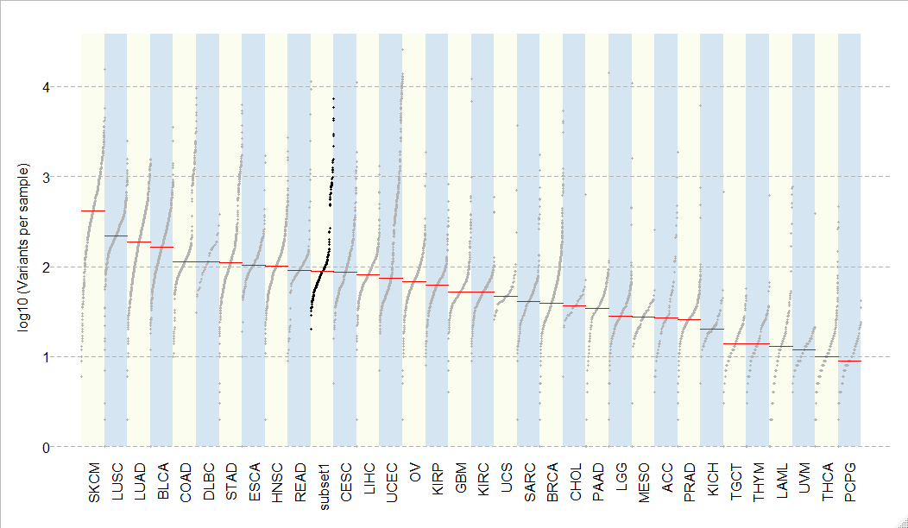

Subset2

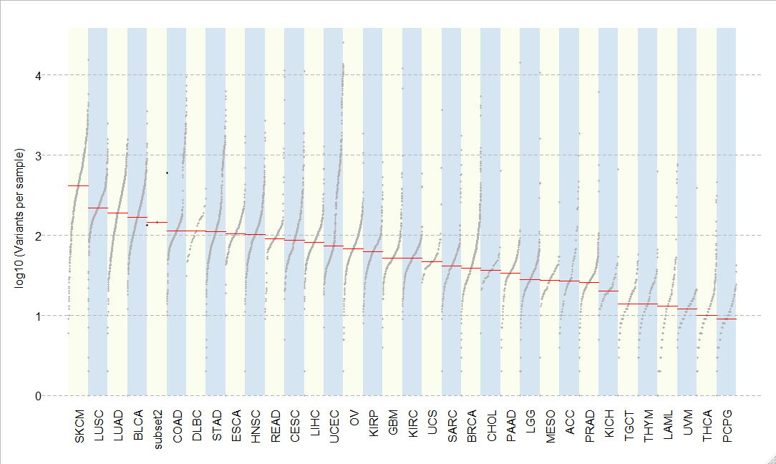

Subset3

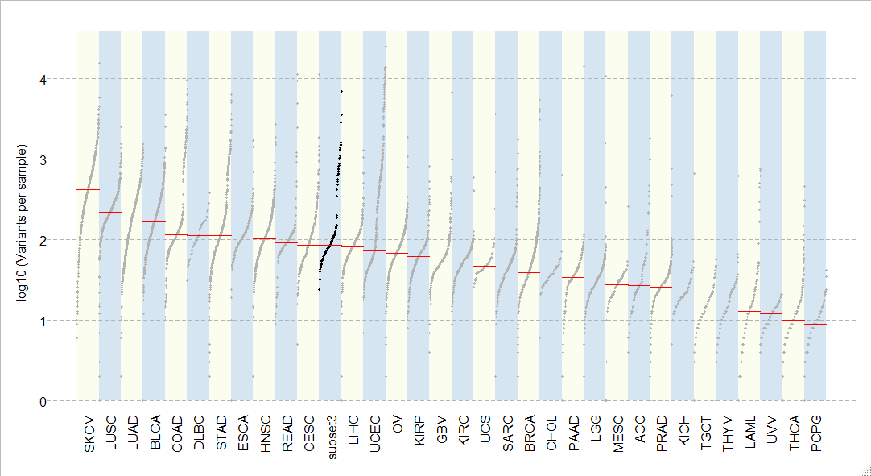

Subset4

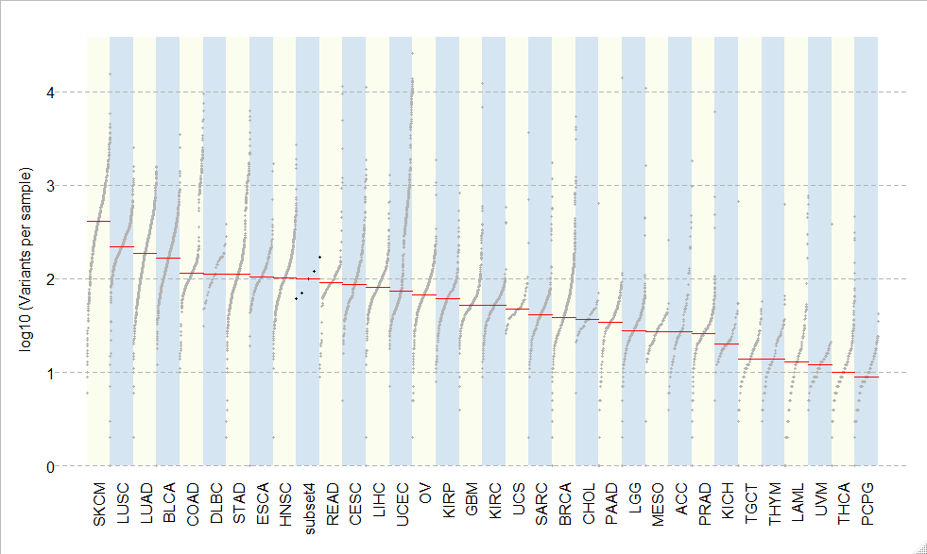

LUSC

Subset1

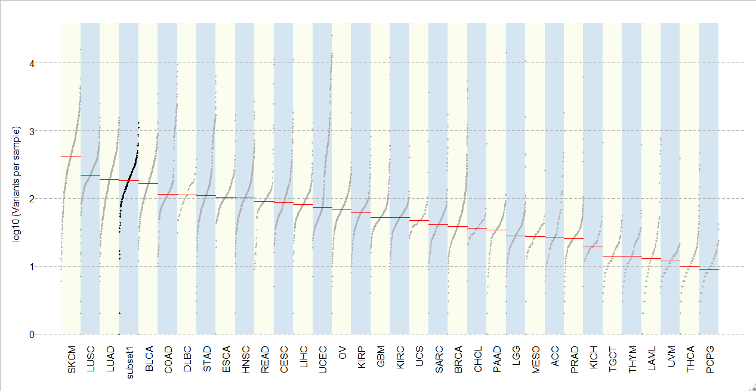

Subset2

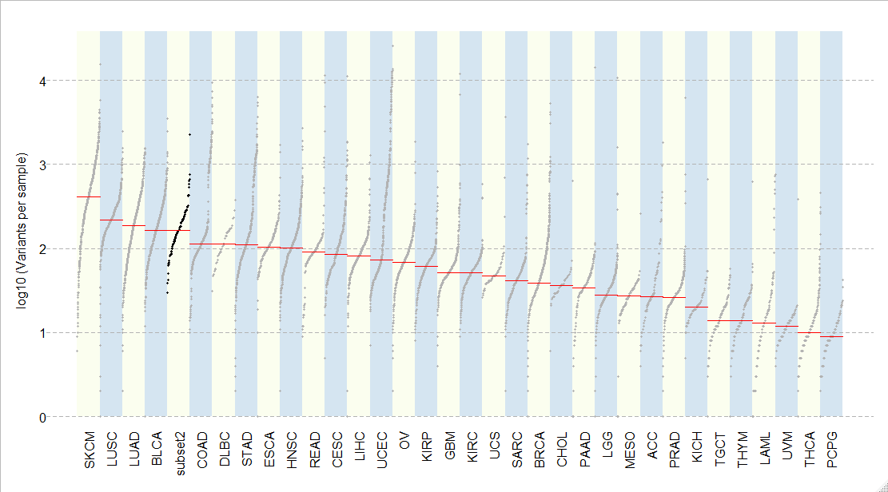

Subset3

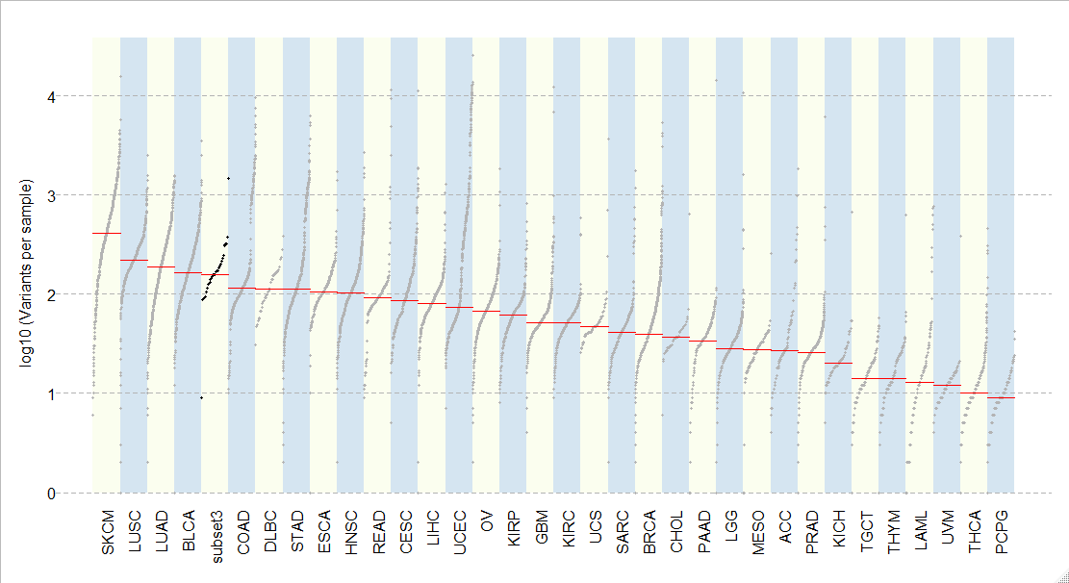

Subset4

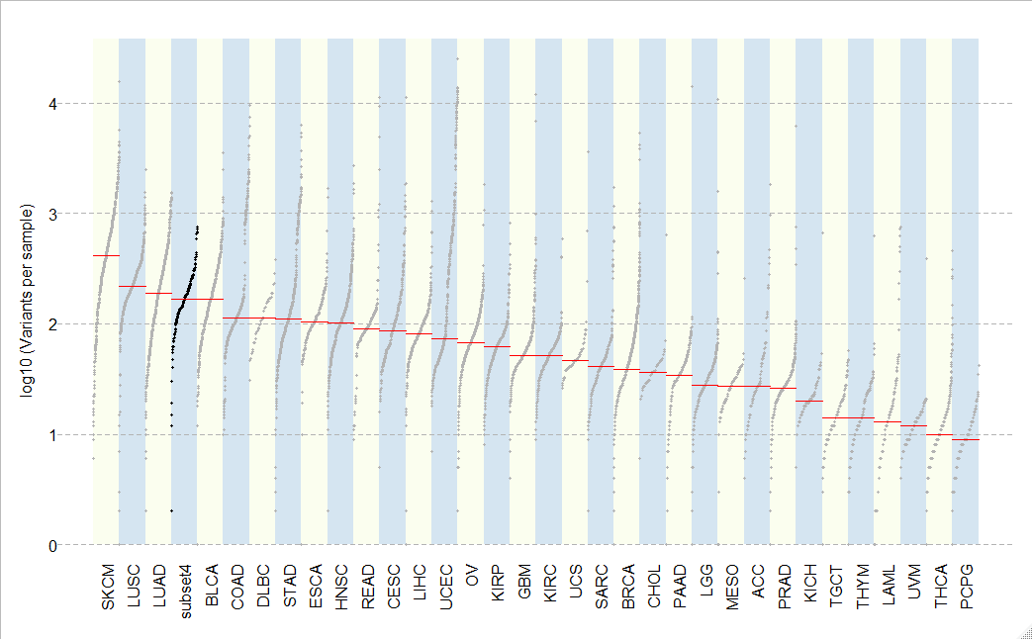

LUAD

Subset1

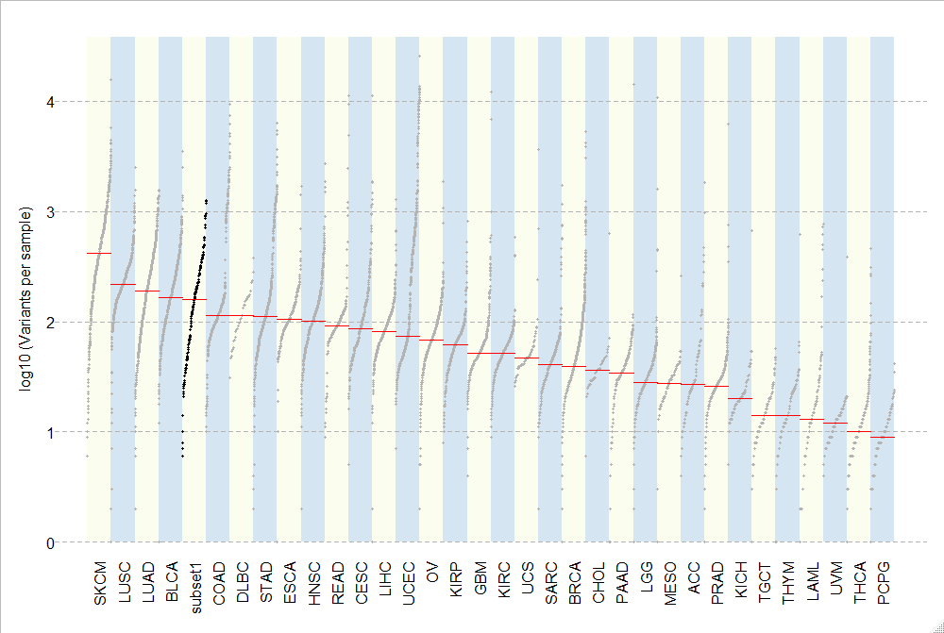

Subset2

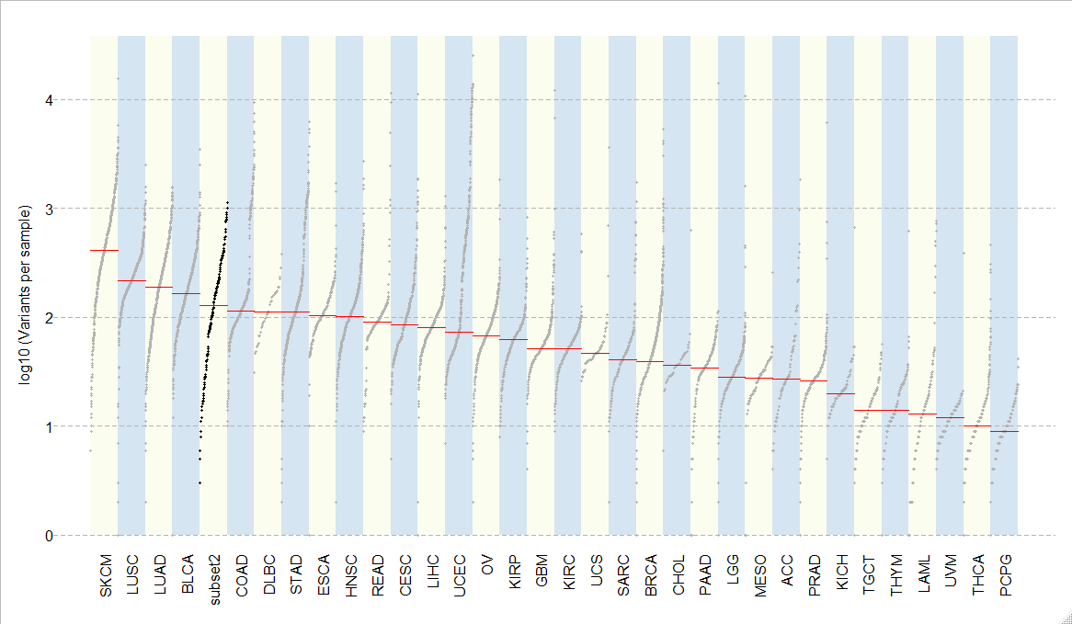

Subset3

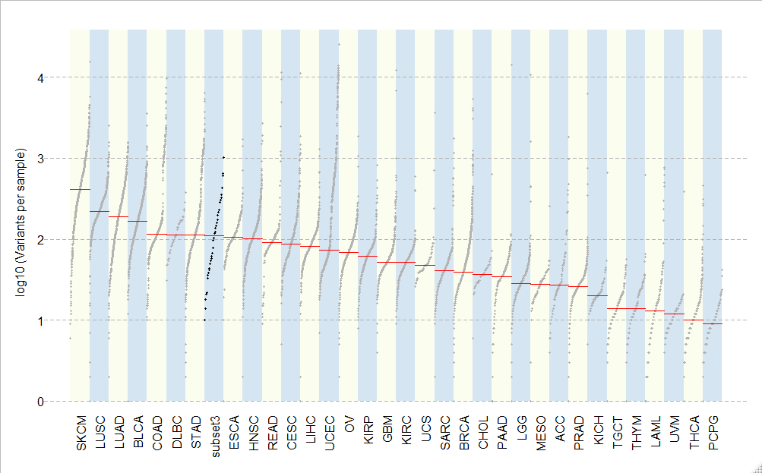

Subset 4

